The Objective of the Sales Dashboard / Business Problem

The objective of the report is to analyze and present comprehensive insights into sales, profit, orders, profit margin, and various comparisons. It aims to provide a clear understanding of key performance indicators and trends using Power BI. The report objectives can be summarized as follows:

1. **Calculate Total Sales:** Calculate and display the total sales value for the selected period, allowing users to understand the overall revenue generated.
2. **Calculate Profit:** Calculate and visualize the total profit achieved based on the sales data, providing insights into the financial performance.
3. **Analyze Orders:** Analyze the number of orders placed during the selected period, helping to identify sales patterns and order trends.
4. **Calculate Profit Margin**: Calculate and visualize the profit margin percentage, enabling users to assess the profitability of products or services.
5. **Compare Sales by Product with Previous Year:** Compare sales performance for each product between the selected period and the previous year, highlighting growth or decline in sales.
6. **Compare Sales by Months with Previous Year**: Compare sales performance across different months between the selected period and the previous year, identifying regions with significant changes.
7. **Display Top 5 Cities:** Present a visualization showcasing the top 5 cities based on sales, allowing users to quickly identify the most lucrative locations.
8. **Compare Profit by Channel with Previous Year:** Compare profit generated by each channel between the selected period and the previous year, indicating improvements or challenges in profitability.
9. **Analyze Sales by Customer and Compare with Previous Year:** Analyze sales data by customer, highlighting the performance of individual customers and comparing it to the previous year.
10. **Create Slicers for Date, City, Product, and Channel:** Enable users to interact with the data by providing slicers for selecting specific dates, cities, products, and channels, allowing for dynamic filtering and personalized analysis.

NB: using the sales analysis report

Steps to follow for an end-to-end Power BI Project

1) Gather Data

Collect the necessary data for your project. This could include data from various sources such as databases, spreadsheets, or web services. Ensure the data is accurate and relevant to your objective. Download the Download section at the end of the page.

2) Power Querry – Data Extract, Transform & Load

Power Query Editor in Power BI is a powerful tool for data cleaning and transformation. We will use it Clean and transform the data to make it suitable for analysis. This may involve removing duplicates, handling missing values, merging datasets, or creating calculated columns.

3) Create a Date Table

To work with Data Analysis Expressions (DAX) time intelligence functions, there’s a prerequisite model requirement: You must have at least one [*date table*](https://learn.microsoft.com/en-us/power-bi/guidance/model-date-tables) in your model.

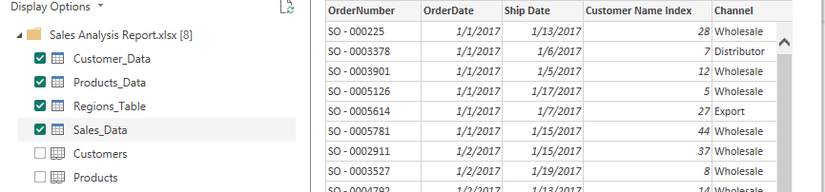

Total_Sales = unicast * salesPrice

Total Cost = [Unit Cost]*[Order Quantity]

NB: Close and Applied

**CREATING DATETABLE:**

First, we need to inform power bi not to create separate time table for us

Go to, files, Options and setting, Option

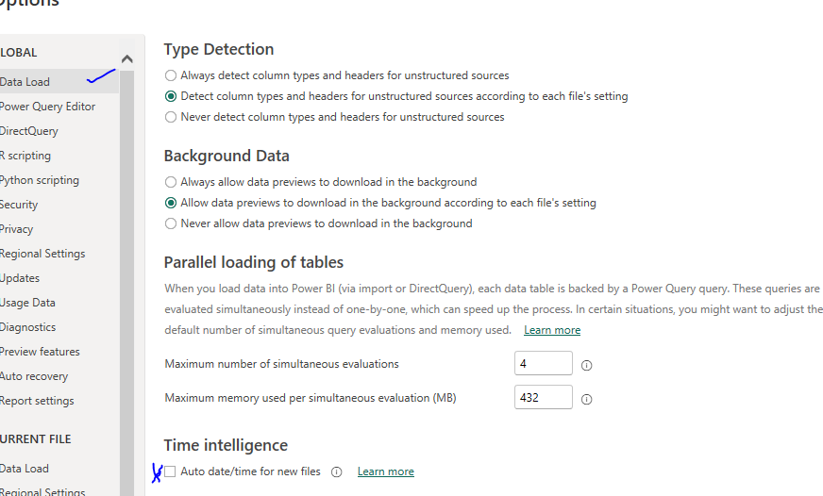

**DATE TABLE:**

Click on any Column and click modelling, new table and paste this

DAX DateTable =

ADDCOLUMNS (

    //CALENDAR(DATE(2020,1,1), DATE(2024,12,31)),

    CALENDARAUTO(),

    "Year", YEAR([Date]),

    "Quarter", "Q" & FORMAT(CEILING(MONTH([Date])/3, 1), "#"),

    "Quarter No", CEILING(MONTH([Date])/3, 1),

    "Month No", MONTH([Date]),

    "Month Name", FORMAT([Date], "MMMM"),

    "Month Short Name", FORMAT([Date], "MMM"),

    "Month Short Name Plus Year", FORMAT([Date], "MMM,yy"),

    "DateSort", FORMAT([Date], "yyyyMMdd"),

    "Day Name", FORMAT([Date], "dddd"),

    "Details", FORMAT([Date], "dd-MMM-yyyy"),

    "Day Number", DAY ( [Date] )

)

Create Data Model in Power BI Desktop

Design and create a data model that represents the relationships between different tables in your data. Establish proper relationships, define keys, and establish hierarchies if needed. This step is crucial for accurate analysis and visualization

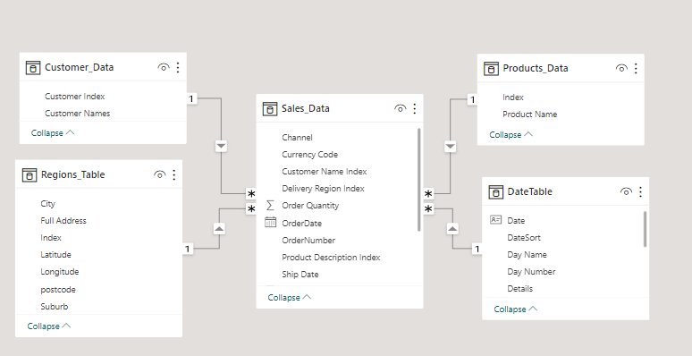

***NB: always delete the existing relationship and create your own ,or use manage relationship to create it***

**DEVELOP REPORTS IN POWER BI DESKTOP**

Use the Power BI Desktop application to create reports based on your data model. Add visualizations such as charts, tables, and maps to represent the data effectively. Apply filters, slicers, and drill-through functionalities to allow users to interact with the data.

* Create Report Background in PowerPoint
* Create Slicers – **Date, City, Product, and Channel**
* Create Dax measures
* Create Visuals:  
  1) Sales By Product and Comparing it with last year’s Sales.  
  2) Sales By Month and Comparing it with last year’s Sales.  
  3) Sales of top 5 Cities  
  4) Compare Profit by channel with Previous year’s Profit  
  5) Sales By Customer and Comparing it with last year’s Sales  
  6) Create Cards for Sales, Profit, Profit Margin & Product Sold

NB: you can add this to date Colum.. Month Sort = FORMAT(DateTable[Date],"YYYY-mm")

Click on the canvas background and use the image you create with power point

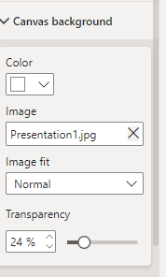

**MEASURE:**

**Profit = totalsales - total cost**

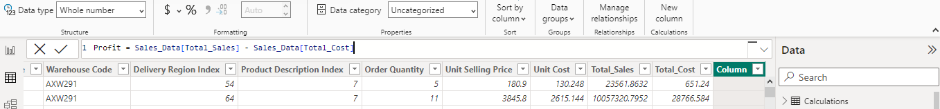

Total Sales = SUM(Sales_Data[Total_Sales])

Sales previous year

Sales PY = CALCULATE([Total Sales],SAMEPERIODLASTYEAR(DateTable[Date]))

Sales - salesprevious year

Sales vs PY = [Total Sales] - [Sales PY]

Sales vs LY %  = DIVIDE([Sales vs PY],[Sales PY])

Profit = SUM(Sales_Data[Profit])

Profit LY =  CALCULATE([Profit], SAMEPERIODLASTYEAR(DateTable[Date]))

Products Sold = SUM(Sales_Data[Order Quantity])

>> Profit = SUM(Sales_Data[Profit])

>> Profit LY = CALCULATE([Profit], SAMEPERIODLASTYEAR(DateTable[Date]))

>> Profit Vs LY = [Profit]- [Profit LY]

>> Profit vs LY % = [Profit Vs LY]/[Profit]

>> Profit Margin = DIVIDE([Profit],[Sales],0)

>> Total Cost = SUM(Sales_Data[Total Cost])

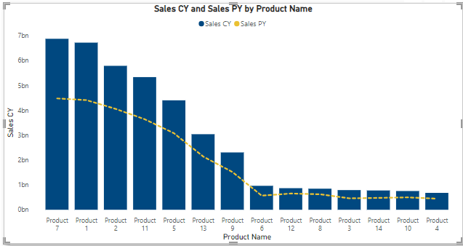

Adding condition formatting to the chart

When the sales of current year ia greater than last year , the bar should be green

Sales vs PY = [Total Sales] - [Sales PY]

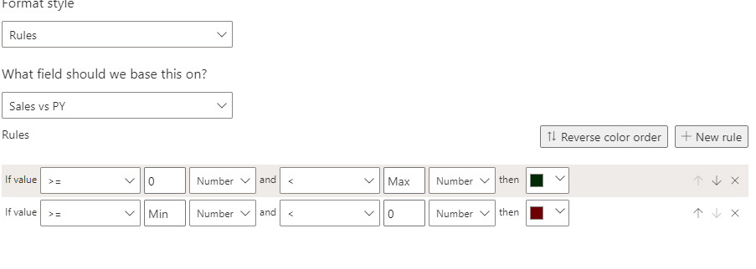

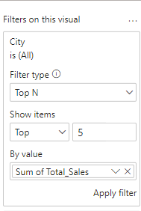

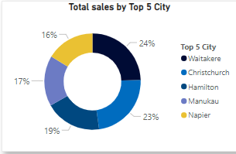

Compare Profit by channel with Previous year’s Profit

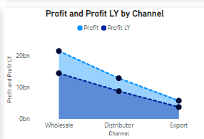

Create Cards for Sales, Profit, Profit Margin & Product Sold

KPI : is use to show how far are u behind your target or how far are u above your target

So u need your target , profit and your value let say date

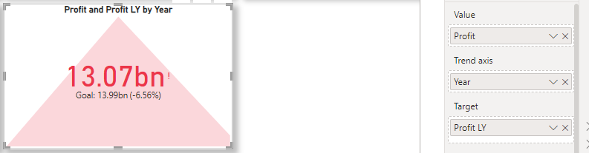

Tooltip:

To create a tootltip, we create new page and change the canvas settings to tools tip  
NB: remember to hide this page from user

